Shiloh Messenger
The Little Country Church With A Big Heart

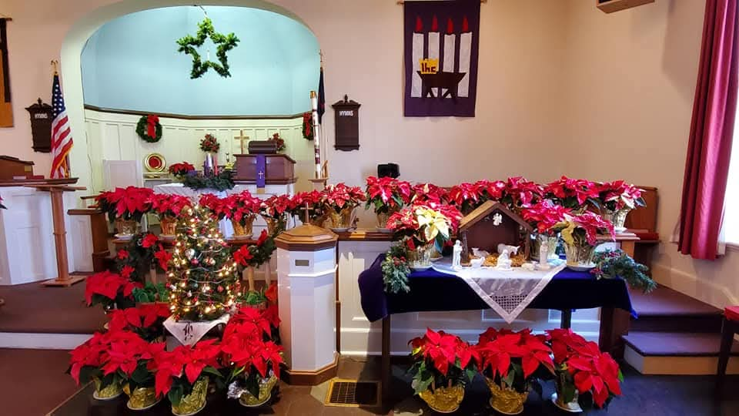

December 2025
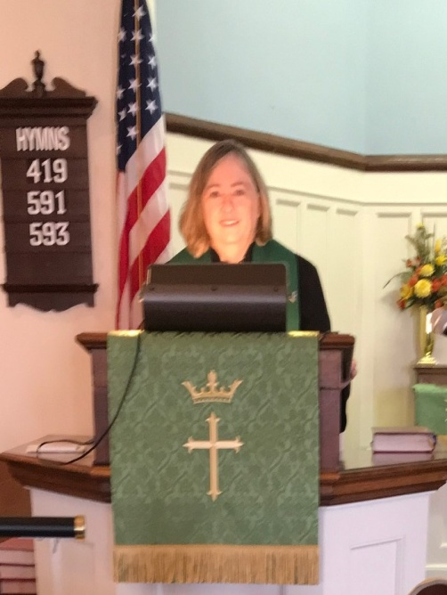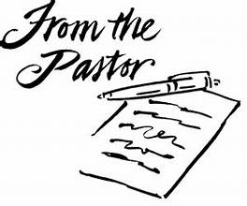

Most of us are at least familiar with Charles Dickens’ classic. A Christmas Carol, which
was originally published in 1843. Dickens’ story about Ebenezer Scrooge has appeared in many forms over the years, including stage and screen versions, made for TV adaptations, opera and ballet versions, and even pop culture takes on the story, such as Scrooge McDuck, Mr Magoo’s Christmas Carol, Scrooged, or Muppet Christmas Carol.
If you have seen any of these, you likely remember that the main character, Scrooge is a man who seems to detest everything there is about the Christmas season – the man who brought us the phrase “Bah! Humbug!” – a man who has been described as “an iconic figure who represents stinginess, greed, and generally being in a terrible mood.” Dickens himself described Scrooge as “a squeezing, wrenching, grasping, scraping, clutching, covetous, old sinner.”
If you know anything else about the story A Christmas Carol—in any of its versions – you know that things won’t stay the same. That things are about to change. I don’t think it’s spoiling anything in the story to say that Scrooge will be taken on a journey that will change his life and redeem his soul. We know that Scrooge, past, present, and future will come together – and eventually, he will be changed. As one commentator reminds us: “Just as Christ brings light and hope to a world in darkness, the events of A Christmas Carol shine light into the darkness surrounding Scrooge’s life, ultimately leading him to embrace the peace, hope, love, and joy we associate with Christmas.”
Over the next few Wednesday nights, I will be leading a study by Matt Rawle, called The Redemption of Scrooge. You are invited to join us as we take a closer look at how a Christmas hating man is transformed, and learns to “keep Christmas well.” In the process, we pray that we can find messages of God’s peace, hope, love, and joy!

Blessings,
Rani

Shiloh U M Church
19731 Shiloh Church Road
Hagerstown, MD 21742
Church office – 301-797-4083
Pastor Rani – Cell: 919-604-5528
Email: rwoodrow@nccumc.org,
bnwoodrow@aol.com

Church Website:
www.shilohumchagerstownmd.com

Sunday School 9:30 am-10:00 am
Sunday Worship Service 10:30 am

Holy Communion:
Sunday, December 7, 2025
Sunday, January 4, 2026

Please remember to submit all announcements and prayer requests in writing to the Church Office or you may email them to: doylefamily51907@gmail.com by Thursday to ensure they make it in the Sunday bulletin.

If you have an immediate prayer request please contact Dianne Keller to begin the Shiloh Prayer Chain.

Bible Study
“The Redemption of Scrooge”
December 3rd 6:30 p.m.
Four Week Study
A group bible study in the Social Hall.
Taught by Pastor Rani

Upcoming Events:
Administrative Council Meetings
Tuesday, December 9th 6:30 p.m.
Tuesday, January 13th 6:30 p.m.


Happy Hearts Luncheon
Thursday, December 11th
Main Street Diner
Waynesboro, PA
12:00 noon

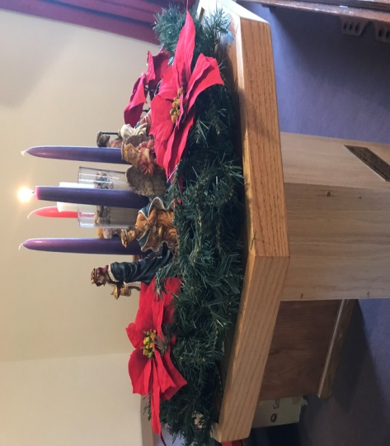
Advent
The season of Advent, which comes from a latin word adventus meaning “coming” or “visit” begins four Sundays before Christmas and ends on Christmas Eve.
Although we are accustomed to celebrating Christmas on a single day, in both Christian tradition on the Church calendar, the Christmas season at sundown on December 24th through Epiphany January 6th. This is sometimes probably referred to as “the twelve days of Christmas. The advent celebration is both a commemoration of Christ’s first coming and an anticipation of His second coming.

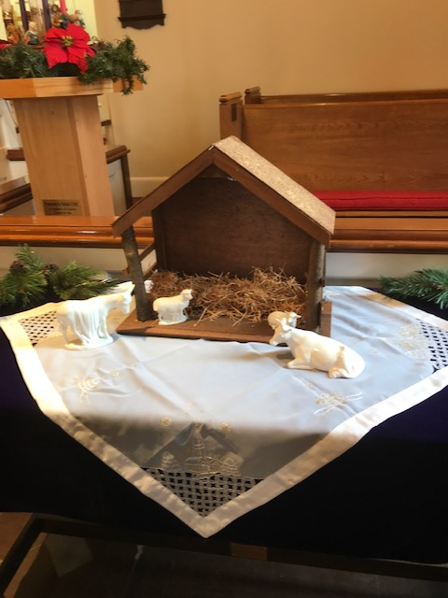
Awaiting Our Savior

The journey to the manger began the first Sunday in Advent with the children’s story. Each Sunday morning during worship service, Jacob will tell the story leading the children to the manger and Jesus’ birth.

 Mitten Tree

Tree located on stage in Social Hall
While you are doing your shopping, remember to pick up mittens, scarves and hats for children that are in need of these items during the cold winter season.

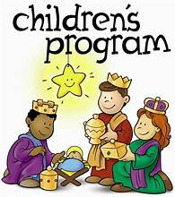

December 7th After worship service
What brings the joy of Christmas more than our children at Shiloh. The smiles on their faces as they sing and recite their various recitations is so heartwarming.
Please stay following worship service and show the little ones your appreciation and support.

For The Children

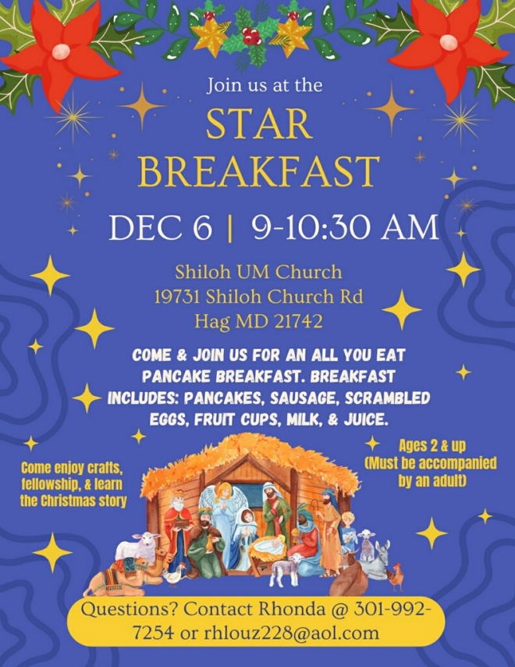


Shiloh Adult Christmas Party
Sunday, December 7th 5:00 pm
Shiloh Social Hall

Menu featuring Beef Brisket, Stuffed chicken breast, Baked Ziti with meat, Baked Vegetable Ziti, , Oven Roasted potatoes, Broccoli with cheese,
Green Beans, Salad, Rolls, Pies, Cookie Tray. $20 per person.

Join us for dinner followed by an evening full of Christmas spirit.

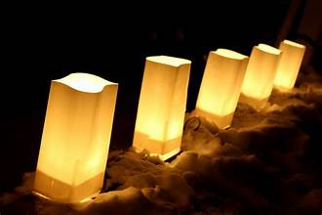
LUMINAIRE SALE
December 7 – December 21
Luminaires for $1.00 each in Honor of or in Memory of loved ones will be lit on Christmas Eve. Help light the paths outside of the church and support the youth in shopping for needy families.


A Christmas card box has been provided in the back of the sanctuary. Save money on postage by sending cards to church members through the Shiloh Christmas “Mailbox”. Please put first and last names on the envelopes.
HOLLY PLACE for the Holly-days!
Shiloh will be collecting items for the residents of Holly Place this Christmas. If you would like to contribute, a box for these items will be placed in the church vestibule. Some requested items by Holly Place are: Soda (regular or diet), graham crackers, animal crackers, “soft” breakfast bars, crackers, popcorn, Kleenex, mouthwash, Fixodent, nail polish, after shave lotion, body spray and socks.

Due by Sunday, December 14th.

Thank You
Thank you to everyone who helped and supported the Pancake Breakfast.
Profit of $1,702.00 was deposited into the Building Fund which helps to maintain our church building.

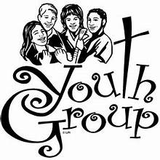
The Youth group would like to thank everyone who voted on our pumpkins.
We raised $210.
December 7- December 21 - Our stockings will be hung with care in the Social Hall to ask for your votes.
All proceeds will help us to shop for gifts to make a merrier Christmas for two families.

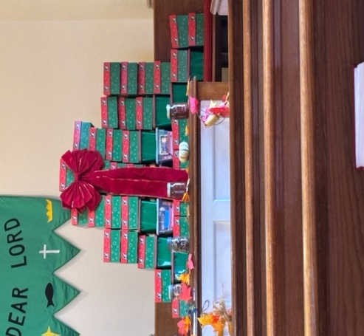
50 Boxes
Thank you to those who filled a shoebox with gifts for Operation Christmas Child.
Many children whom have never received a gift will be blessed by the boxes you packed for our Operation Christmas Child project. Thank you for your participation and may you be blessed this Christmas season by the knowledge that a child on the other side of the world is feeling your love because of your willingness to pack a shoebox.
 Ladies Tea Ministry
December 19th 11:00 a.m.

The ladies will meet to assemble Christmas bags with assorted snacks and cookies for the Shut-Ins at 11:00 a.m.
“Bring your own bag lunch” followed by the business meeting and delivery of gift bags to each individual.
All ladies are invited

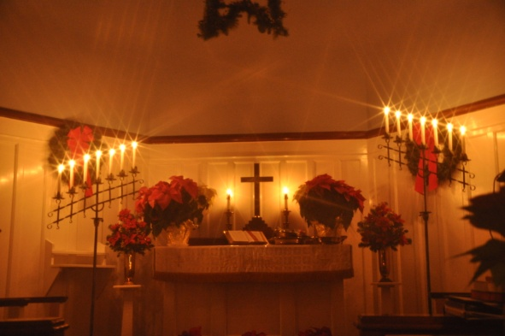
Christmas Eve
Candlelight Service
Wednesday, December 24th 7:00 p.m.

Christmas Eve service beginning with special music at 7:00 p.m. Please share your talent and sign up for special music.

Worship service begins at 7:30 p.m. Come join us for a candlelight service and singing carols as we celebrate Jesus’ birth.
We are pleased to have Washington Square members joining us.
Offering will be sent to Everstand, formerly Board of Child Care.

Little Christmas Candle”
As the light from each small candle
Joins with others, watch it grow
From a solitary shining
To a heavenly peaceful glow.

Let the glow from all the candles
Remind you of God’s love
And that he watches over you
From his Kingdom up above.

We’ll leave the church together
The candle’s flame will die away
But the love of Christ our Saviour
Will be ours through all our days.

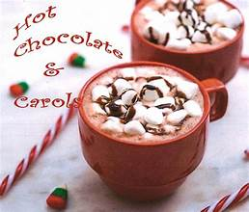
Coffee, Carols, and Cocoa
Sunday, December 21, 3:00 p.m.
Washington Square UMC, LeFew Hall
A time for fellowship and Christmas Songs
Everyone is invited

1 Richard Keller
7 Elizabeth Jones
8 Christopher Trovinger
11 Alyssa Dorsey
11 Carolyn Brooks
11 Jimmy Koontz
11 Gerald Frey Sr
12 Lester Trovinger
22 Kathy Roberts
23 Jeanne Reeser
24 Nellie Mae French
25 David Frey
25 Kevin Jaye
27 Laura Miller
28 Ashlyn Gardner
30 Pamela Noble



6 Charles & Jane Frey
29 Frank & Carolyn Brooks



Shiloh Homebound & Shut-Ins
Remember these members with prayers, cards, phone calls and other acts of kindness.

Helen Davis
355 Antietam Drive
Hagerstown, MD 21742

Jeanne Reeser
c/o Filcare
13016 Spickler Road
Clear Spring, MD 21722

Gin and Dean Stenger
128 E. Lee Street
Hagerstown, MD 21742

Rev Wilson Shearer
149 S Hunter Hwy Apt 311
Drums, PA 18222-2444

Toni Gosnell
13338 Marquise Dr
Hagerstown, MD 21742

Mary Barnhart
844 Spruce St
Hagerstown, MD 21740

The Best Christmas Gift
By Helen Rice

A long time ago in Bethlehem
In a manager so forlorn
God gave the world a “Christmas gift”
The night His Son was born.
He wasn’t wrapped in pretty paper
But in swaddling clothes He laid
The animals watched over Him
As the shepherds knelt and prayed.
Wise men came to worship Him
And brought Him gifts, so rare.
Choirs of angels sang His glory
Their carols filled the air.
A star shone bright up in the sky
And lit up all the earth
The night God gave the world a Savior
Through Jesus’ humble birth.
As we open Christmas presents
All gaily wrapped and trimmed,
Let us remember that holy night
And open our hearts to Him.
And as we sing our carols
And as the bells will ring
Let’s thank God for the best gift of all,
Jesus Christ our King
Alleluia.


YOUTH PANCAKE BREAKFAST
JANUARY 31, 2026
Cost By Donation
Sausage Gravy Sold By The Quart $7

