Shiloh Messenger

April – May – June
2024

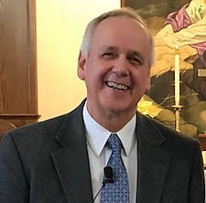

Shiloh Church Family,
Didn’t we have a blessed Lenten Season and Easter this year. Thanks to all who helped with worship, and with all the activities and events during Lent, Holy Week, and Easter Day. As we continue the 50-day Easter Season and see the new life springing forth in all of creation this time of year, we are reminded each day of the new life made possible for us through the death, resurrection, and reign of our Lord and Savior, Jesus Christ!
I’ve heard from several people that the Season of Lent was meaningful and helpful this year; that they feel renewed in their relationship with the Lord and energized to keep growing in faith and service. You committed to participate in Sunday Worship, Lent Wednesday Worship, and Holy Week and Easter services and activities, and it helped you experience the renewal our Lord offers during Lent.
During Sunday worship in April, May, and June, we’ll be continuing our journey with Jesus: his appearances following the resurrection, his ascension into heaven, and his formation of the church and sending of the Holy Spirit on Pentecost. We’ll also look at Christ’s work in the early church. As we do, I continue to encourage you to actively look and listen for the ways Christ is speaking to you in your life right now through these Bible stories.
I can’t believe how fast this year with you is going. It has been a year of transition for you in preparation for receiving a pastor who will serve alongside of you for the next chapter in Shiloh’s history, and it has truly been a joy to shepherd you during his transaction year. I’m thinking you should hear soon on the appointment of a new pastor to serve Shiloh and Washington Square beginning on July 1.
During our year together you have continued to show the signs of a healthy church.
Here are some that I see:
Worship – A dedicated team of volunteers makes worship happen each week at Shiloh. You attend worship regularly, and you actively participate in worship. During Lent several of you attended the Lent Wednesday services. These are good signs of a healthy church.
Growth in Faith – By practicing your spiritual disciplines of worship, prayer, Bible Study, Holy Communion, and growing and serving together as a church family, you’re continuing to deepen your relationship with God. You had a special Bible Study during Advent and Sunday School each week. During Advent and Lent, you had a special Children’s Time at worship, and you recently restarted offering Children’s Time every Sunday. The Happy Hearts group meets monthly, and several of you are partnering with extended church family at Washington Square UMC. We recently had a baptism and several of our youth will be confirmed in May and can become members. These are good signs of a healthy church.
Growth in Service – Through your own individual care giving – cards, calls, visits and more –through the Prayer Chain and our prayers during worship, through the Ladies Tea Ministry, through delivery of poinsettias to Shut-Ins at Christmas, and Easter Baskets, you’re caring for your Shiloh brothers and sisters in need. And you’re reaching out into the community to provide care giving in many ways: Weekly Micah’s Backpack deliveries, supplies for Holly’s Place, the School Supply Giveaway, Operation Christmas Child and the Community Trunk or Treat and Easter Egg Hunt. These are good signs of a healthy church.
Youth Fellowship – It’s great to see our youth actively participate: in worship, as they meet monthly, and as they engage in service projects throughout the year. During June, they’ll be hosting the youth of our district with a bonfire event. A highlight of worship each week is greeting the youth as they hand us devotional take- aways on our way out of church. The vitality of our youth is a good sign of a healthy church.
Lay Leadership – Shiloh has a committed group of volunteer laity who lead and serve in leadership positions and on committees. Shiloh could not operate smoothly without the effective leadership these individuals provide. It has been good to see younger adults willing to step forward to help with church leadership and to start preparing themselves to step into more significant leadership roles. A healthy church is one where each worshiper shares in the responsibility to give generously of their time, talents, and financial resources.
Sharing Our Faith with Others – I’ve seen some of you share your faith with those outside the Shiloh church family. I know of examples where people are now worshiping at Shiloh because they were invited by you. Our Lord is counting on each of us to share with others the difference Christ has made in our life and to invite others to church. This is a sign of a healthy church.
Keep it up Shiloh, you’re on the right track! I’m looking forward to serving alongside of you these next three months and I can’t wait to hear about all the great ways you will grow and serve in the future. God Bless, Pastor Bob

Shiloh U M Church
19731 Shiloh Church Road
Hagerstown, MD 21742
Church office – 301-797-4083
Pastor Bob – Call or text – 240-385-6833
Email to revbsnyder@comcast.net
Adminisrative Office Hours at Shiloh
Wednesday & Friday 8:00 – Noon

Church Website:
www.shilohumchagerstownmd.com

Sunday School 9:30 am-10:00 am
Sunday Worship Service 10:30 am

Holy Communion:
Sunday, April 7, 2024
Sunday, May 5, 2024
Sunday, June 2, 2024

Please remember to submit all announcements and prayer requests in writing to the Church Office or you may email them to: doylefamily51907@gmail.com by Thursday to ensure they make it in the Sunday bulletin.

If you have an immediate prayer request please contact Dianne Keller to begin the Shiloh Prayer Chain.

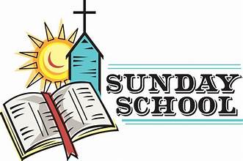

Sundays – 9:30 – 10:00 am
Children and Adult Classes
The Sunday School adult class is a study of biblical principles and spiritual growth. A group who share their personal faith in meaningful discussion and build relationships with each other.
Sunday school for the children teaches at an early age the importance of learning the love of Jesus through bible stories.
Won’t you come and participate in this fellowship with others?

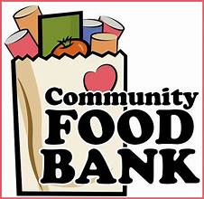
We are so blessed. During these difficult times there are so many more families than ever struggling to pay bills and feed their families. We can do our part by donating to the Community Food Bank in Hagerstown. For years this ministry has been close to the hearts of our congregation.
If you would like to contribute, you can give cash or mail a check to the church with notation “Food Bank”. The church will forward to St Mark’s Lutheran Church.
The Community Food Bank feeds an average of 800 families and 500 individuals a month.

And do not forget to do good and to share with others, for with such sacrifices God is pleased.
Hebrews 13:16

Administrative Council Meetings
Tuesday, April 9th 6:30 pm
Tuesday, May 14th 6:30 pm
Tuesday, June 11th 6:30 pm

If you have a concern or request to be brought before the board, please attend the meeting or see a member of the board.

Remember our Shut-Ins with a card or a phone call.
It means so much to them to know Shiloh has not forgotten them.

Flowering of the Cross

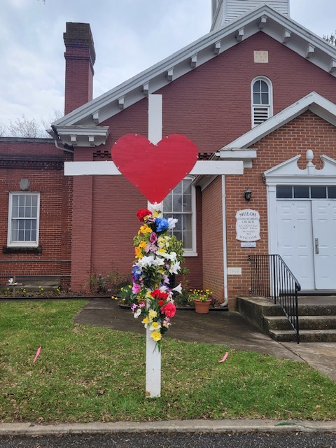

Flowers were placed on the cross by the congregation during the Sunrise service on Easter Sunday.
The flowering of the cross is a beautiful way to symbolize the new life that emerges from Jesus’ death on Good Friday.

BAPTISM
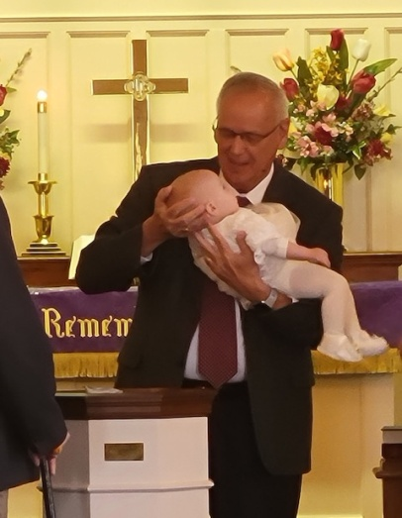
Ayria Juliet Phillips
Parents: Terry and Amber Phillips

Infant baptism is a ritual that carries deep spiritual meaning for both the child and the parents. It is believed to be a moment when the child is blessed and embraced by the love of God and the faith community.
Represents hope and promise for the child’s future. Through baptism, parents make promises to raise the child in Christian faith, teaching them the values and beliefs of Christianity.

Luncheon
NOTE: New date - Friday, April 19th

Tea Ministry cont’

Beginning May – the Tea will be held on 3rd Friday.

The Tea is open to all ladies of the church and friends.

Happy Hearts Fellowship
“Friends we are. Friends we’ll be
Friends forever you and me.”

2nd Thursday each month:

Apr 11th 12:00 noon – Hagerstown Diner
May 10th 12:00 noon – Social Hall
June 6^{th –} 12:00 noon - Hagerstown Diner

We hope you will consider joining us for fun and fellowship

Thank You
Thanks to everyone who donated to the Easter baskets. The Children’s Dept filled 9 baskets to give to the shut-ins. It is so important for Shiloh to let them know they are not forgotten.
Thanks to everyone who helped or donated filled eggs and candy to the Easter Egg Hunt. There were 50 children in attendance and 2500 plastic eggs were hidden. This event was open to the community so others can experience the love of Shiloh for children.
Our thanks to Nevalene and those who volunteered to make this year another successful one for the children.

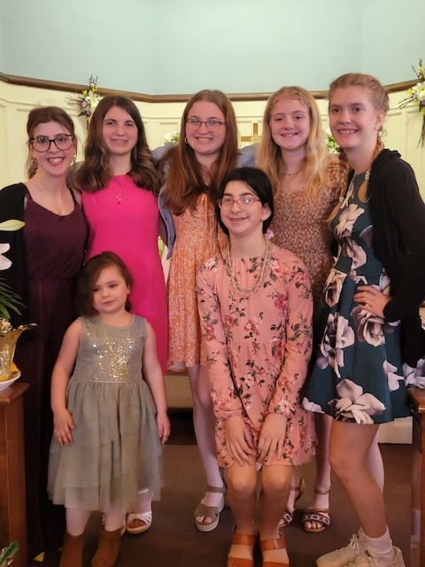
Shiloh Youth
The youth with the help of Washington County Rabbit & Poultry Club, were able to pack 50 lunches to help feed the homeless.
It’s a blessing to be a blessing.

The youth “Egged” the houses of the younger kids of the church. Everyone had a great time and the kids loved their treats.

Covered Dish Social
April 21 5:00 pm

The youth is inviting you to join them for “Our Dare the Pastor” Social. The youth has come up with things for Pastor Bob to join them in.
Come watch, eat and have an evening of lots of laughs and fun.

Bonfire for Cumberland-Hagerstown District Youth: June 19
We will need donations from our church family. Watch for more information later.

The youth have some special things coming your way in the next few months. They have some surprises.

Get Ready!!

Sunday, May 12th

Under My Mother’s Spell

M- is for the Memories, I have of her today.
O –is for the Others, she helped along her
way.
T-is for tears she shed, of joy, sorrow and
pride
H-is for the Home she made with lots of
love inside
E-is for the Easiness, with which she met all
strife.
R-is for the rich Rewards, of a good and
fruitful life.

All these things, I saw in her
She taught me very well.
As long as I live, I hope and I stay
Under “My Mother’s Spell.”

Written by Helen Rice

Mothers and Fathers Recognized:
Mothers – Sunday May 12th 10:30 am service
Fathers – Sunday June 16th 10:30 am service

Mother-Daughter Banquet
Sunday, May 19th 5:00 pm
Covered Dish Dinner
Open to all ladies. You are either a mother or daughter.
This is an enjoyable evening of fun, fellowship, and of course, good food.
All men encouraged to come out and help serve and clean up

Lord, we remember those who made the ultimate sacrifice for the freedoms we enjoy every day.
We think of how they followed the footsteps of you son, Jesus Christ. Please hold our servicemen and women in your strong and loving arms. Cover them with your sheltering grace and presence as they stand to protect us.
Please supply them with courage to face each day and may they trust in Your Mighty Power.
Amen
Sunday, June 16

What Makes a Dad
God took the strength of a mountain,
The majesty of a tree,
The warmth of a summer sun,
The calm of a quiet sea,
The generous soul of nature,
The comforting arm of night,
The wisdom of the ages,
The power of the eagle's flight,
The joy of a morning in spring,
The faith of a mustard seed,
The patience of eternity,
The depth of a family need,
Then God combined these qualities,
And then there was nothing more to add,
He knew His masterpiece was complete,
And so, He called it - Dad.

VACATION BIBLE SCHOOL
June 24 – June 26
Come join us for Bible School
More details at a later date
An open invitation is extended from Washington Square UMC to join in their upcoming events:
Women’s Prayer Breakfast – 1st Saturday each month, 8:30 am Hagerstown Diner
Men’s Prayer Breakfast – 4th Tuesday each month, 7:30 am Hagerstown Diner

APRIL
2 – Dean Stenger
6 – Tammy Frey
8 – Erin Myers
9 – Alayna Rumbaugh
11 – Joe Frey
13 – Nataleigh Jean Jones
17 – Rhonda Parks
22 – Monty McManus
26 – Jeremiah Baker
26 – Tish Frey
27 – Walt Welling
28 – Joyce Jones
29 – Emerson Kuhn

MAY
1 – Cody Jones
6 – Kathy Jo Hefner
12 – Jim Barnhart
13 – Loralli Snyder
20 – Evan Frey
23 – Gerald Frey Jr
25 – Amber Keck
26 – Jenny Belliotti
30 – Kayla Trovinger

JUNE
2 – Jeff Parks
3 – Zachary Frey
3 – James Shank
5 – Terrie Shank
7 – Christopher Taylor
11 – Dianne Keller
12 – Kayleigh Shank
14 - Margo Trovinger
14 – Mark Trovinger
15 – Jay Doyle
22 – Alexis Mills
25 – Addyson Bruchey
27 – Arjean Ritter
28 – Shannon Uzelac

APRIL
14 – Walter & Fran Taylor

MAY
4 – Charles & Jones Jones
12 – Bobby & Pam Noble
19 – Jacob & Ashley Doyle
23 – Wayne & Lene’ Rumbaugh
25 – Tim & Doris Snouffer
JUNE
9 – Ryan & Amanda Shank
12 – Wayne & Toni Gosnell
17 – Jeff & Rhonda Parks
23 – Marvin & Linda Ridenour

Note: Check website for services and events which may not appear in the newsletter.

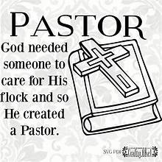
Because this newsletter is published through the month of June, it is the last one during the time of Pastor Bob being with us before his retirement. We want to express our heartfelt appreciation to Pastor Bob and Donna for the ministry of love and inspiration they have bestowed on our church family. We want to express our appreciation also to Loralli for her participation in the youth group.
Pastor Bob, you have touched each one of our lives in so many ways. May God continue to bless you in your retirement, which we know is well deserved.
You will always remain in our hearts.

