Shiloh Messenger

*The Little Country Church With A Big Heart*

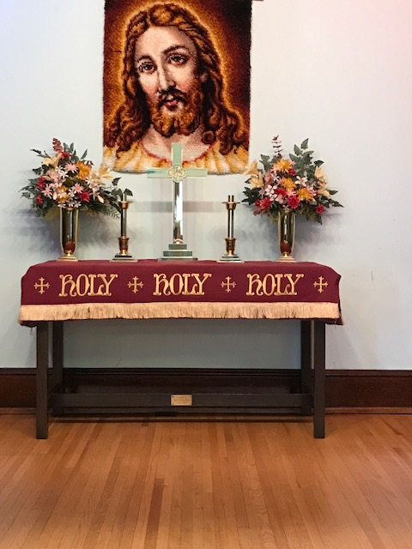

April – May – June

2025

**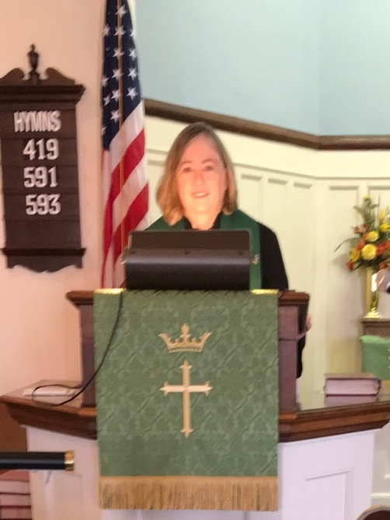 *From the Pastor’s Desk***

If someone were to ask me to name my favorite hymn, I would definitely have to say that it is Natalie Sleeth’s “Hymn of Promise.” It is one of those songs that brings back wonderful memories of another place and time. I vividly remember the first time I sang the choral arrangement, at a music workshop in 1985, the year before it was originally published. I remember both the simple but beautiful tune and the message of hope conveyed through the words.

It was several years later when I would learn more about the background of “Hymn of Promise.” Apparently, Natalie Sleeth wrote these words filled with a message of hope in 1985, after facing the death of a friend, after thinking about the seeming opposites of winter and spring, and after reading a T.S. Eliot poem which contained the phrase, “In our end is our beginning.”

There’s a song in every silence, seeking word and melody;

There’s a dawn in every darkness, bringing hope to you and me.

From the past will come the future; what it holds, a mystery,

Unrevealed until its season, something God alone can see.

What Natalie Sleeth did not know at the time she wrote these words was that they would continue to speak God’s word of hope in her own life.

Natalie Sleeth was scheduled to be a guest conductor at a children’s choir festival at Pasadena Community United Methodist Church in St. Petersburg, Florida. She had recently finished her work on this piece and agreed to have the children premier the work at this festival. Natalie’s husband Ron, a professor at Illiff School of Theology in Denver, joined her on this trip to Florida. Almost immediately after their return to Denver, Ron Sleeth was diagnosed to be in the final stages of terminal cancer. In the final few weeks of his life, Ron planned his own memorial service and requested that the “Hymn of Promise,” with its message of hope, be included in this service.

As we move forward from this Lenten season into Easter, we need to remember that God’s hope and promise is a gift given to each of us. I challenge you to live in faith, to receive God’s gift, and to share God’s gift of promise with others.

Blessings,

Rani

**Shiloh U M Church**

19731 Shiloh Church Road

Hagerstown, MD 21742

Church office – 301-797-4083

**Pastor Rani Woodrow**

Cell: 919-604-5528

Email – rwoodrow@nccumc.org

Church Email – shilohumc@myactv.net

Church Website:

[www.shilohumchagerstownmd.com](http://www.shilohumchagerstownmd.com)

Sunday School 9:30 am-10:00 am

Sunday Worship Service 10:30 am

**Holy Communion:**

Sunday, April 6, 2025

Sunday, May 4, 2025

Sunday, June 1, 2025

Please remember to submit all announcements and prayer requests in writing to the Church Office or you may email them to: doylefamily51907@gmail.com **by** **Thursday** to ensure they make it in the Sunday bulletin.

If you have an immediate prayer request please contact Dianne Keller to begin the Shiloh Prayer Chain.

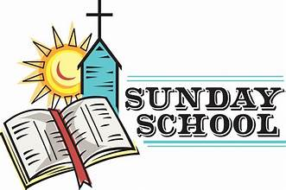

**Sundays – 9:30 – 10:00 am**

**Children and Adult Classes**

The Sunday School adult class is a study of biblical principles and spiritual growth. A group who share their personal faith in meaningful discussion and build relationships with each other.

Sunday school for the children teaches at an early age the importance of learning the love of Jesus through bible stories.

Won’t you come and participate in this fellowship with others?

*Thank You to the Youth*

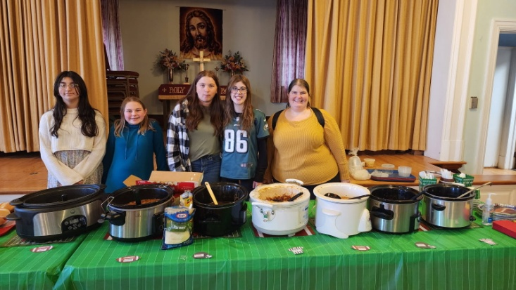

A variety of soups and sandwiches!

The Soup-er Bowl luncheon was a success and enjoyed by all .

**Youth News**

The Youth Group will be going to the homes of the younger youths again this year for our “You’ve Been Egged” event on Friday, April 18th.

Also, we are working on a few Community Service Events and other events. Keep watching for more details*. Rhonda*

***Thank You***

Dear Friends of the Food Bank,

St Mark’s would like to thank Shiloh for the monetary gift of $45 to the Food Bank in the month of February.

Your commitment to helping individuals and families in our community is sincerely appreciated.



**Administrative Council Meetings**

Tuesday, April 8th 6:30 pm

Tuesday, May 13th 6:30 pm

Tuesday, June 10th 6:30 pm

If you have a concern or request to be brought before the board, please attend the meeting or see a member of the board.

**Happy Hearts Fellowship**

*“Friends we are. Friends we’ll be*

*Friends forever you and me.”*

**2nd Thursday each month:**

Apr 10th 12:00 noon – Main St. Diner

May 8th 12:00 noon – Social Hall

June 12th –  12:00 noon - TBD

*We hope you will consider joining us for fun and fellowship*

**Baskets for Shut-Ins**

The Children’s Dept will be collecting items for Easter baskets for our Shiloh shut-ins. They enjoy receiving these baskets as well as a visit. They are very happy that the church members remember them during this season. If you would like to donate items for our baskets, the children will be filling them on Palm Sunday, April 13th.

If you would like to donate any items for the baskets, a box will be set up in the church vestibule. Such items would include fruit cups, aplesauce and pudding cups, crackers, cookies, wrapped candies, soft breakfast bars, note cards, pens, etc.

If you have any questions, please see Dianne or Nevalene.



**Holy Week**



**Palm Sunday, April 13th**

Palm Sunday is the day we celebrate the triumphal entry of Jesus into Jerusalem, one week before His resurrection. As Jesus entered the holy city, a large crowd gathered around Him. The actions of the crowd along the road gave the rise to the name “Palm Sunday. The crowd spread their cloaks on the road and they cut branches from the trees and spread them on the road. John records the detail that the branches they cut were from palm trees. (John 12:13)

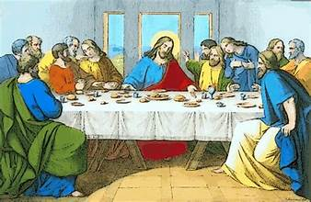

**Maundy Thursday Service**

**April 17th 7:00 pm**

Maundy Thursday is the day during Holy Week in which we recognize and celebrate when Jesus washed the feet of his disciples and established the act of **communion** at the **Last Supper**. This was a profound time in which Jesus ministered to and taught his disciples. They could not understand why Jesus would wash their feet. He was Lord and he was their master, surely it should be the other way around. But Jesus taught them about loving one another, humility, and servanthood.

So, as we partake in communion, we are submitting to Jesus command to remember him by taking and sharing bread and wine.

**Good Friday**

**April 18th**

For Christians, Good Friday is an important day of the year because it celebrates what we believe to be the most momentous weekend in the history of the world. Ever since Jesus died and was raised, Christians have proclaimed the cross and the resurrection of Jesus to be the decisive turning point for all creation. Paul considered it “of first importance” that Jesus died for our sins, was buried, and was raised to life on the third day, following what God has promised in the scriptures (1 Corinthians 15:3)

***Washington Square invites everyone to attend their Good Friday service at 7:00 pm.***

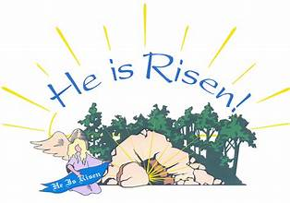

**Sunrise Service**

**April 20th 6:30 a.m.**

Communion will be served outside during the service.

Breakfast following the service.

**Regular Worship Service 10:30 a.m.**

 **April 19th 1:00 pm**



***Sunday, May 11th***

**Under My Mother’s Spell**

**M**- is for the Memories, I have of her today.

**O** –is for the Others, she helped along her

way.

**T**-is for tears she shed, of joy, sorrow and

pride

**H**-is for the Home she made with lots of

love inside

**E**-is for the Easiness, with which she met all

strife.

**R**-is for the rich Rewards, of a good and

fruitful life.

All these things, I saw in her

She taught me very well.

As long as I live, I hope and I stay

Under “My Mother’s Spell.”

*Written by Helen Rice, Shiloh Church*

**Mothers and Fathers Recognized:**

Mothers– Sunday May 11th 10:30 am service

Fathers– Sunday June 15th 10:30 am service

**Mother and Daughter Tea Party**



**Sunday, May 18th 3:00 p.m.**

In lieu of the annual Mother-Daughter banquet, the Shiloh Ladie’s Tea ministry invites all ladies to attend the afternoon Tea Party

Additional information will be announced at a later date.

**May 26th**

Lord, we remember those who made the ultimate sacrifice for the freedoms we enjoy every day.

We think of how they followed the footsteps of you son, Jesus Christ. Please hold our servicemen and women in your strong and loving arms

**An open invitation is extended from Washington Square UMC to join in their upcoming events**:

Women’s Prayer Breakfast – 1st Saturday each month, 8:30 am Hagerstown Diner

Men’s Prayer Breakfast – 4th Tuesday each month, 7:30 am Hagerstown Diner

**Baltimore-Washington Annual Conference**

Pastor Rani will be attending our annual conference from Tuesday, May 13th until Thursday, May 15th.



**New Directory**

We are doing a new directory with addresses and phone numbers.

If you have had a change, please give information to:

Ginger [gingerfrey1@yahoo.com](mailto:gingerfrey1@yahoo.com) or

Tammy [T.Frey@aol.com](mailto:T.Frey@aol.com)

**VACATION BIBLE SCHOOL**

**June 17 – 19**

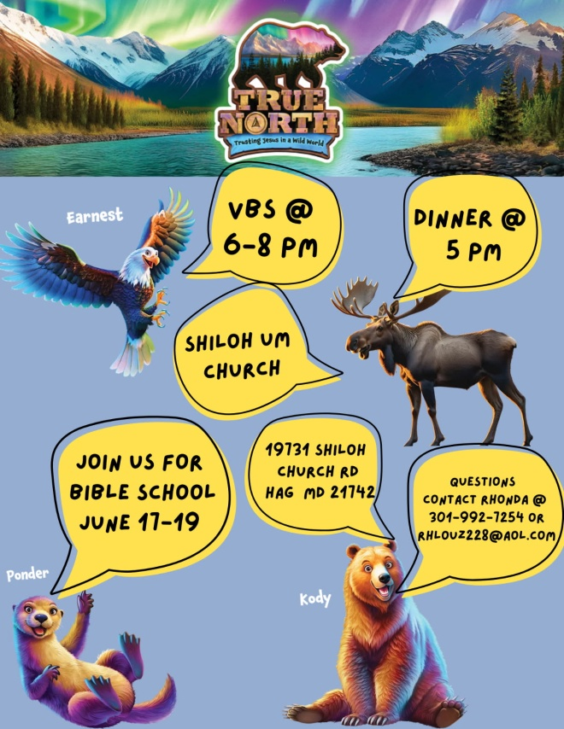

***Father’s Day***

**Sunday, June 15th**

**A Father’s Faith**

A Father’s love,

a reflection of God’s grace,

His faith shining brightly,

In every embrace.

With words of wisdom

And a heart that forgives,

He guides his children

To the life God gives.

He teaches us patience,

Compassion, and trust,

To walk in the footsteps

Of the one who is just,

Through his actions,

He reveals God’s plan.

A faithful father,

A spiritual man.

On this Father’s Day,

We honor and pray,

For the fathers who lead us

On the righteous way.

May God’s blessings

Surround them each day,

As they inspire us to walk

In His perfect way.

**Thanks to everyone who donated items and to those who took their Saturday to help with the Pancake Breakfast on March 15th.**

**Profit of $1,486 to the Building Fund to cover building maintenance.**



**APRIL**

2 – Dean Stenger

6 – Tammy Frey

8 – Erin Myers

9 – Alayna Rumbaugh

11 – Joe Frey

17 – Rhonda Parks

26 – Jeremiah Baker

26 – Tish Frey

27 – Walt Welling

28 – Joyce Jones

**MAY**

1 – Cody Jones

17 – Kaitlyn Livengood

20 – Evan Frey

23 – Gerald Frey Jr

25 – Amber Philips

26 – Jenny Belliotti

30 – Kayla Trovinger

**JUNE**

1 – Chris Livengood

2 – Jeff Parks

3 – Zachary Frey

3 – James Shank

5 – Terrie Shank

7 – Christopher Taylor

11 – Dianne Keller

12 – Kayleigh Shank

14 - Margo Trovinger

14 – Mark Trovinger

15 – Jay Doyle

27 – Arjean Ritter

28 – Shannon Uzelac



**APRIL**

14 – Walter & Fran Taylor

**MAY**

4 – Charles & Jones Jones

19 – Jacob & Ashley Doyle

23 – Wayne & Lene’ Rumbaugh

25 – Tim & Doris Snouffer

**JUNE**

12 – Wayne & Toni Gosnell

17 – Jeff & Rhonda Parks

23 – Marvin & Linda Ridenour

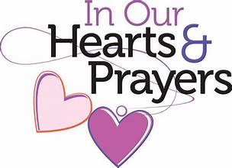

Our thoughts and prayers continue to be with our shut-ins and those who are unable to join us in Sunday worship service.

Jeanne Reeser

Dean and Gin Stenger

Rev Wilson Shearer

Helen Davis

***As we celebrate the joy of His Resurrection, May the blessings of peace, gladness and hope fill your heart and home.***

***Have A Happy Easter***