Shiloh Messenger

*The Little Country Church With A Big Heart*

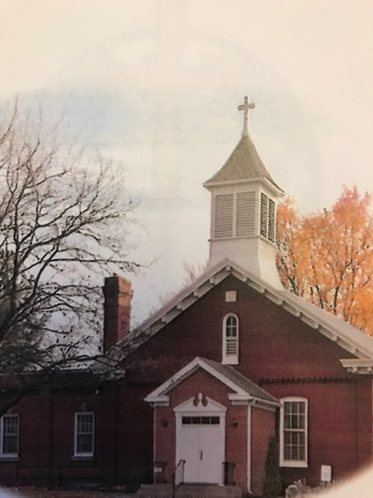

**January – February – March**

**2025**

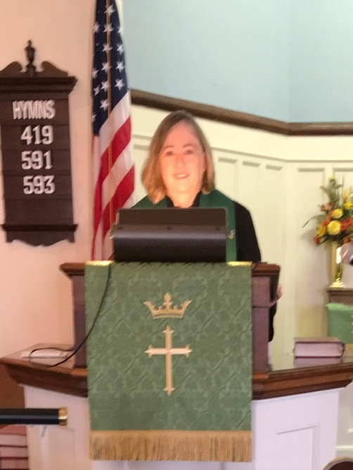



**Shiloh U M Church**

19731 Shiloh Church Road

Hagerstown, MD 21742

Church office – 301-797-4083

Pastor Rani – Cell: 919-604-5528

Email: [rwoodrow@nccumc.org](mailto:rwoodrow@nccumc.org),

[bnwoodrow@aol.com](mailto:bnwoodrow@aol.com)

**Church Website:**

[www.shilohumchagerstownmd.com](http://www.shilohumchagerstownmd.com)

Sunday School 9:30 am-10:00 am

Sunday Worship Service 10:30 am

**Holy Communion:**

Sunday, February 2, 2025

Sunday, March 9, 2025

Please remember to submit all announcements and prayer requests in writing to the Church Office or you may email them to: doylefamily51907@gmail.com **by** **Thursday** to ensure they make it in the Sunday bulletin.

If you have an immediate prayer request please contact Dianne Keller to begin the Shiloh Prayer Chain.

**Cancellation Policy:** Inclement Weather, church cancellations. “One Call” by phone. Tammy Frey will call and leave message. . A mass email will also be sent out and also notification by Facebook. If you do not receive notification by either methods please let us know.



If you would like to volunteer to read scriptures during the worship service, please sign the sheet on the table in the back of the sanctuary.



Share your musical talent with the congregation during the Sunday morning worship service.



**Administrative Council Meetings**

Tuesday, February 11, 2025 6:30 p.m.

Tuesday, March 11, 2025 6:30 p.m.

**Thank You, Shiloh**

The Food Bank at St Mark’s Lutheran Church wishes to acknowledge and thank you for your generous gifts we received this past year. Your generouosity and compassion is a blessing to our community that will make a difference in the lives of those in need.

We feed an average of 400 families a month and your donation makes it possible to continue these services despite the economic distress of those who serve.

Frankly, we could not do what we do without donors such as you.

*“Do not neglect to do good and to share what you have, for such sacrifices are pleasing to God” Hebrews 13:16*



***The Spirit of Giving***

**Thanks to everyone who extended their Christmas giving to the following projects**:

*Operation Christmas Child*

*Everstand (Board of Child Care)*

*Adult Sunday School class – REACH*

*Shiloh Tea Ministry – Cookies and Christmas Bags*

*Poinsettias for Shut-Ins*

Our Mitten Tree was ladened with hats, scarves and gloves. Thanks to those who shopped and to Arjean who sat for many hours crocheting.

We are so pleased to imagine the children who were in need for these winter items are now protected from the winter cold.

***Journey of our Shoeboxes.***

Children of Botswana and Tangania, located in East Africa, were blessed with the shoeboxes sent by Shiloh. Thanks to everyone who filled a box.

**‘Thank You**” to those who donated items for Holly Place. We received many useful items for the residents. The spirit of giving always shines at Shiloh. Dianne

** **Luncheons**

*Friends we are. Friends we’ll be*

*Friends forever You and me*

**Thursday, February 13th**

Main Street Diner, Waynesboro, PA

12:00 Noon

**Thursday, March 13th**

Church Social Hall

12:00 Noon

*Join us for lunch and conversation*

*****Ladie’s Tea Ministry***

Friday, February 21st 1:00 pm

Friday, March 21st 1:00 pm

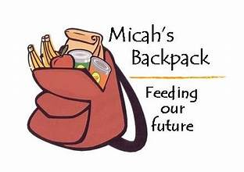

**The following items needed:**

Easy MacCups or packets

Cup of Soup

Ramen Noodles

Rice-A-Roni Cups

Oatmeal

Granola Bars

Individual packs of crackers

Individual packs of pretzels

Fruit Snacks

Pop Tarts

Rice Krispy Treats

Pudding Cups

Jello Cups

Cheese Crackers

Microwave Popcorn

Individual packs of Goldfish

Hot Chocolate Packets

Individual packets of Cookies

Individual bags of Chips

This is an ongoing project for Shiloh.

These packs are given to school children over the weekends that do not have enough to eat.

***Youth Events***



**Saturday, February 15th 7 – 11 am**

**Benefit: Shiloh Youth Group**

**Cost by Donation**

Pancakes, Sausage, Sausage Gravy, Puddin,Fruit, Coffee, Juice and Milk

*Pre-Order Sausage Gravy $7.00 quart*

*Contact Rhonda 301-992-7254 –* [*rhlouz228@aol.com*](mailto:rhlouz228@aol.com)



***Soup-er Bowl Luncheon***

**Sunday, February 9th**

***Join the Youth Following Worship Service***

Variety of soups, sandwiches and desserts

Cash Donations Accepted

Take out meals will be available

Benefits the Youth Group

Questions? Contact Rhonda



Meal begins at 6:00 pm

Service begins at 7:00 pm

**March 5th Ash Wednesday**

Shiloh UMC Service: 7:00 pm

**March 12th Emmanual UMC**

**March 19th Shiloh with**

**Washington Square**

**March 26th Grace UMC**

**April 2nd John Wesley UMC**

**April 9th Otterbein UMC**

***Lent*** is a time when Christians observe the spiritual disciplines of fasting, prayer, study and worship as a commemoration of the forty day experience the Lord had in the wilderness.

Lent is a season for us to reflect and remember the passion of Christ. No one can conceive the suffering and pain our Lord endured for the salvation of our lives. He was called to be God’s Son “to be wounded for our transgressions, to be bruised for our iniquities.” What a price Jesus paid for our sins! Through Christ, God made a covenant with us that everyone who believes in His son, Jesus, and confesses Him as Lord and Savior of their lives be given the gift of eternal life.



**Pancake Breakfast**

**March 15th**

*Benefit: Building and Improvement Fund*

**Improvements to our Building in 2024:**

1. Replaced damaged ceiling tiles in social hall, and painted damaged wall in the sanctuary.

Cost of $2,600

**Improvements:**

1. Painted outside brick, door and windows.

Cost of $15,000.

Projects paid from the Building and Improvement Fund.



***Happy Birthday!***

**January**

6 – Ralph Shank

10 – Allison Keller

18 – Artie Barnhart

**February**

1 – Austin Zimmerman

12 – Nevalene Uzelac

24 – Shelby Koontz

28 – Rhonda Uzelac

**March**

1 – Brian Myers

9 – Joyce Welling

20 – Angie Koontz

21 – Dave Roberts

25 – Alivia Koontz

27 – Lillian Doyle

30 – Gin Stenger



**March**

13 – Walter & Joyce Welling

15 – David & Jenny Belliotti

19 – Jay & Debbie Doyle

20 – Dave & Kathy Roberts

22 – Ralph & Terrie Shank

24 – Gerald & Ginger Frey

29 – Joe & Debbie Frey

31- Dean & Gin Stenger

If you have a birthday or anniversary not listed, please email me [gingerfrey1@yahoo.com](mailto:gingerfrey1@yahoo.com)



***Our thoughts and prayers continue to be with all our shut-ins and church family who are not able to join us for worship on Sundays.***

Jeanne Reeser

Dean and Gin Stenger

Rev. Wilson Shearer

Helen Davis

*March 9*